Jalen Powell

February 6, 2023

Comp 4200

Assignment 2

1. A = { w | length of w, |w|, is a multiple of 3 }



1. B = {11, 111}

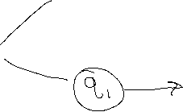

1. C = { w | w contains an even number of 0’s and contains exactly two 1’s }



* To prove that regular languages are closed under the set difference operation by contradiction, we must start by stating the theorems,

1. We know that regular languages are closed under union.
2. Regular languages are closed under complementation:

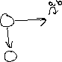

1. Regular languages are closed under intersection.

